**Assessing the Feasibility and Environmental Impact of Replacing Coal Power Plants with Nuclear Energy in India**

# Executive Summary

Today, the energy situation in India is at a crossroads: rising demands for sustainable and reliable sources of energy lie alongside a growing urgency to counter environmental concerns. The dominant fuel for electricity production in India is coal, which carries high emissions of CO₂, SO₂, and PM. This project titled "Feasibility and Environmental Impact Assessment of Replacing Coal Power Plants with Nuclear Energy in India" explores the possibility of replacing India's present coal-based energy generation with nuclear energy. It details the study's insights into cost efficiency, environmental benefits, and socio-economic implications thus enabling a strategic roadmap for policymakers, energy sector stakeholders, and the government.  
  
**Objective of the Experiment**  
This paper evaluates the economic and environmental feasibility of substituting coal with nuclear power in India for electricity generation. The paper focuses on cost-benefit scenarios, emissions reduction potentials, energy production reliability, and regional socioeconomic impacts of a large-scale nuclear transition.  
  
**Approach and Methodology**  
The project uses an integrated approach combining data collection, modeling, and scenario analysis:  
**Cost-Benefit Analysis**: Comparing capital expenditures (CapEx), operational expenditures (OpEx), and transition costs associated with coal and nuclear power plants, this is used as a basis in comparison for metrics such as NPV and IRR, used to determine whether or not a nuclear investment would pay off in the long term.  
**Environmental Impact Simulation**: Emission reduction scenarios are modeled over a 10-, 20-, and 30-year timeline to give a more comprehensive overview of potential reductions in CO₂, SO₂, and PM.  
**Energy Production Reliability**: The project compares nuclear power's higher capacity factor and consistent energy production with coal, showing that nuclear is suitable for meeting India's growing energy demands.  
**Socioeconomic and Employment Impact**: An employment impact analysis of a transition from coal to nuclear addresses requirements for transitions in the workforce, including retraining costs, and local economic effects.  
**Localized Environmental Benefits:** This study also measures regional emissions reductions, health cost savings, and water usage improvements in coal-dependent regions.  
**Implementation Plan and Policy Recommendations**: The phased roadmap identifies concrete, actionable milestones over the next 30 years and policy recommendations to support such outcomes, including carbon taxes on coal, financial incentives for nuclear, public information measures, etc.  
Key Outcomes  
It shows that a gradual shift towards nuclear power is beneficial on many counts of economics, environment, and society:  
  
**Economic Feasibility:** Although nuclear power plants have higher initial CapEx, they have relatively lower OpEx and a more stable long-term value. The NPV and IRR analyses indicate that nuclear power becomes economical only after 20-30 years, especially if subsidy and carbon pricing policies support it.  
**Environmental Benefits:** A complete replacement of coal with nuclear power will reduce up to 479 million tons of CO₂ emission annually. Major reductions in SO₂ and PM, and therefore in air quality improvement in areas where coal dominates, would be seen.  
**Energy Security:** The high capacity factor and consistent operation make nuclear power more reliable than coal and align with India's energy independence objective, thus reducing its reliance on imported fossil fuels.  
**Socioeconomic Impact**: A shift from coal to nuclear would eliminate coal-related jobs, but it opens new opportunities in nuclear sectors. An estimated investment in retraining and job transition programs can be used to address this employment shift.  
**Policy Recommendations**:  
This study comes up with several actionable recommendations to ease the coal-to-nuclear transition:  
**Financial Incentives**: Provide tax credits, low-interest loans, and capital subsidies to offset the otherwise high CapEx of nuclear projects. Carbon Tax on Coal: Implement a gradual carbon tax on the coal power that would drive the industry toward nuclear and other cleaner sources of energy. Worker Transition Programs: Training and transition financing for workers displaced from decommissioned coal plants. **Public Outreach and Education**: Organize public education campaigns on the benefits of nuclear power and the impacts of coal on the environment and health.

Conclusion In summary, the shift to nuclear power can be a possible way forward for India towards achieving environmental, economic, and energy security goals. The steps for implementation involve step-by-step policies and financial motivation with support towards the development of the workforce. The report contains recommendations and a road map for a sustainable, secure, and low emissions future for India.

# Introduction

Coal is the largest source of energy for India, meeting about 70% of its energy needs. This is very dangerous and causes extensive environmental, health, and economic problems since the burning of such an enormous quantity of coal emits enormous quantities of GHGs and other air pollutants. The world has been strongly urging India to reduce its carbon footprint and start transitioning towards clean sources of energy.  
  
**Background and Importance**  
Its environment impact is rather significant with high emissions of carbon dioxide (CO₂), sulphur dioxide (SO₂) and particulate matter that contribute to air pollution, climate change. According to the Ministry of Power, the Central Electricity Authority expects India's energy demand growth to be consistently over several decades. It will lead to intense environmental damage regarding air quality, water resources, and public health, especially in areas highly dependent on coal-based energy. Meeting this demand through coal would be disastrous.  
  
Nuclear energy could maintain the meeting of energy demand by India. It gives a high-capacity factor on the production of nuclear electricity that is reliable and continued in nature, so dependency of the nation over the fossil fuel is lesser.  
Unlike coal, nuclear plants emit negligible CO₂ and virtually no SO₂ or PM, making them an attractive option for achieving India's environmental goals. Moreover, the progress in nuclear safety technology and waste management is further enhancing the feasibility of nuclear power as a long-term energy solution.  
  
**Objectives of the Study:**  
This study would target the assessment of viability and environmental benefits in using nuclear energy over coal in power generation in India, with the main objectives given as:  
**Economic Feasibility**: Determine capital expenditures (CapEx) and operational expenditures (OpEx) of nuclear power vs coal in general.  
**Environmental Impact:** Measure any possible reductions in CO₂, SO₂, and PM emissions if coal-fired power were replaced with nuclear.  
**Energy Production Reliability**: To compare the ability factors and reliability of nuclear versus coal-based energy production.  
**Socio-economic Impact**: Investigate the employment impact of nuclear transition on coal-dependent regions, taking into account the amount of retraining required and other economic benefits.

Recommendations for policies: Recommendations for policy changes, incentives, and phased strategies toward nuclear expansion.  
**Significance of the Transition**  
The integration of nuclear power can take India closer to its commitments in the Paris Agreement, where India has promised to reduce its emissions intensity by 33-35% by 2030 compared to 2005 levels. Nuclear power, as a low-carbon, high-reliability energy source, opens strategic opportunities for diversifying India's energy mix, securing energy, and reducing its environmental footprint.  
Besides, substitution of coal with nuclear energy will also remove air pollution, hence reducing health care costs due to respiratory diseases and improving the quality of life of citizens, particularly in industrially and coal-dense regions.  
  
**Scope of the Report**  
This report discusses various stands in the move from coal to nuclear and provides an all-rounded perspective on some of the probable advantages or disadvantages of the shift.  
 **Cost-Benefit Analysis**: Extensive financial comparison between coal and nuclear with potential subsidies and cost saving. Environmental Impact Simulation: Projection of emissions under different nuclear replacement scenarios. Energy Generation Modeling: Nuclear energy supply capability for higher reliability of energy supply in India. Socioeconomic and Regional Analysis: Effects of jobs, retraining, and localized benefits. Implementation Plan- Roadmap with key milestones, action, and key policies to be implemented over a phased period for smoother change. This report would, in turn, inform the roadmap that would become actionable for stakeholders and policymakers to guide India's energy transition from coal to nuclear power.

# Methodology

This research study employs a well-structured methodology that unifies data collection, modeling, and scenario analysis toward an assessment of the replacement of coal-based power plants with nuclear energy in the country of India. Its methodology includes several stages, beginning with data acquisition, including the analysis of cost-benefit scenarios, environmental impact simulation, energy production modeling, and a detailed socio-economic assessment. Each is set up to achieve clear objectives and deliver actionable conclusions.  
  
Data Sources  
Data in this study came from credible sources to ensure accuracy and relevance in the evaluation of the transition from coal to nuclear. Key sources include:  
  
Central Electricity Authority (CEA): Data on capacities and operating parameters of coal and nuclear power plants, regional projections of power demand.  
International Energy Agency (IEA): Supplies data on global and regional markets for energy, shedding light on the cost trend for nuclear and coal.  
Ministry of Power, Government of India: National energy policies, emissions targets, and renewable energy initiatives.  
Environmental Protection Data: This data comprises emissions data for CO₂, SO₂, and PM associated with coal and nuclear power plants. Sources include the Ministry of Environment, Forest and Climate Change and open-source databases such as OpenAQ.  
Estimations of costs and information regarding subsidies in the energy sector gathered from public databases and financial reports of institutions such as the World Bank and India's Ministry of Finance.

|  |  |  |  |  |  |
| --- | --- | --- | --- | --- | --- |
| Plant | Capacity_MW | Lifespan_years | CO2_Emissions_tons_per_year | SO2_Emissions_tons_per_year | Operational_Cost_Million_USD |
| Coal_Plant_A | 500 | 40 | 500000 | 20000 | 6 |
| Coal_Plant_B | 750 | 50 | 750000 | 25000 | 7.8 |
| Coal_Plant_C | 1000 | 45 | 1000000 | 30000 | 10.200000000000001 |
| Coal_Plant_D | 750 | 45 | 600000 | 25000 | 9 |

Table 1 - Standardized Coal Data

|  |  |  |  |  |  |
| --- | --- | --- | --- | --- | --- |
| Plant | Capacity_MW | Construction_Cost_Million_USD | Operational_Cost_Million_USD | Lifespan_years | CO2_Emissions_tons_per_year |
| Nuclear_Plant_A | 1000 | 4500 | 50 | 60 | 500 |
| Nuclear_Plant_B | 1200 | 5000 | 55 | 60 | 600 |
| Nuclear_Plant_C | 1500 | 6000 | 60 | 60 | 700 |

Table 2 - Standardized Nuclear Data

|  |  |  |  |  |  |  |  |  |
| --- | --- | --- | --- | --- | --- | --- | --- | --- |
|  | count | mean | std | min | 25% | 50% | 75% | max |
| Capacity_MW | 4 | 750 | 204.1241452319315 | 500 | 687.5 | 750 | 812.5 | 1000 |
| Lifespan_years | 4 | 45 | 4.082483 | 40 | 43.75 | 45 | 46.25 | 50 |
| CO2_Emissions_tons_per_year | 4 | 712500 | 217466.47251166482 | 500000 | 575000 | 675000 | 812500 | 1000000 |
| SO2_Emissions_tons_per_year | 4 | 25000 | 4082.483 | 20000 | 23750 | 25000 | 26250 | 30000 |
| Operational_Cost_Million_USD | 4 | 8.25 | 1.791647286716892 | 6 | 7.35 | 8.4 | 9.3 | 10.200000000000001 |

Table 3 - Coal Data Summary Metrics

|  |  |  |  |  |  |  |  |  |
| --- | --- | --- | --- | --- | --- | --- | --- | --- |
|  | count | mean | std | min | 25% | 50% | 75% | max |
| Capacity_MW | 3 | 1233.3333333333333 | 251.66114784235833 | 1000 | 1100 | 1200 | 1350 | 1500 |
| Construction_Cost_Million_USD | 3 | 5166.666666666667 | 763.7626158259733 | 4500 | 4750 | 5000 | 5500 | 6000 |
| Operational_Cost_Million_USD | 3 | 55 | 5 | 50 | 52.5 | 55 | 57.5 | 60 |
| Lifespan_years | 3 | 60 | 0 | 60 | 60 | 60 | 60 | 60 |
| CO2_Emissions_tons_per_year | 3 | 600 | 100 | 500 | 550 | 600 | 650 | 700 |

Table 4 - Nuclear Data Summary Metrics

The following observations are obtained from EDA:  
1. Distribution of Plant Capacity:  
It is observed that, overall, nuclear plants have larger capacities compared to coal plants. The range of capacity amongst the nuclear plants goes up to 1500 MW, as compared to the range observed in the case of coal plants.  
  
2. CO₂ Emissions:

The coal plants emit much higher CO₂ every year compared to the nuclear plants. This again reflects on the concern of coal as an environmental pollutant energy vector.  
  
3. Lifespan Comparison:  
While coal plants may operate for 40 to 50 years, nuclear plants can remain online for nearly 60 years.

4. Operational Costs:  
The average running cost for coal plants is higher compared to that of nuclear plants; hence, nuclear is long-term cost-effective, although construction costs are much higher.

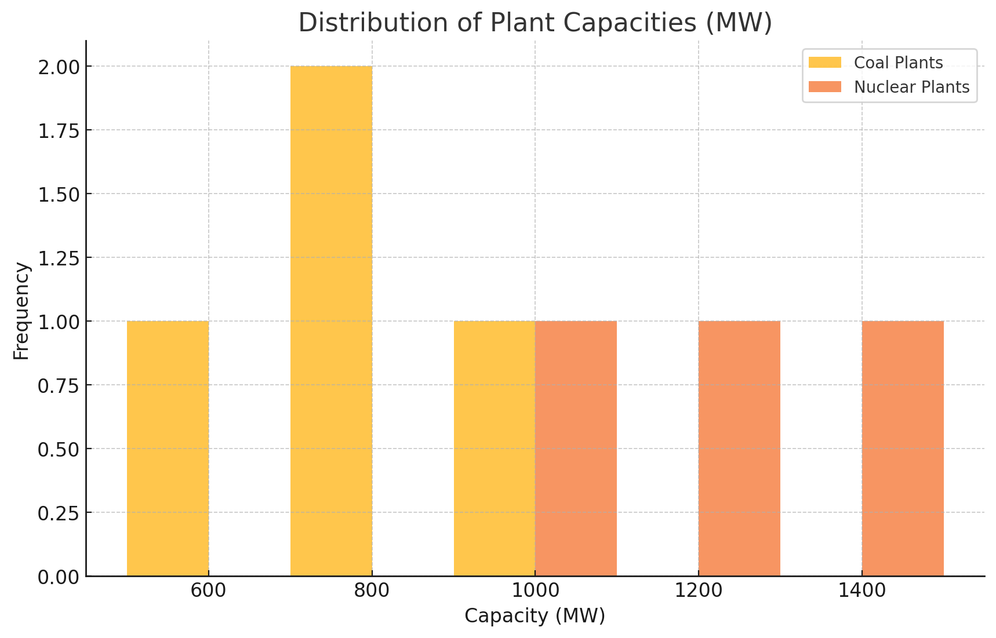

Figure 1 - Distribution of Plant Capacities (MW)

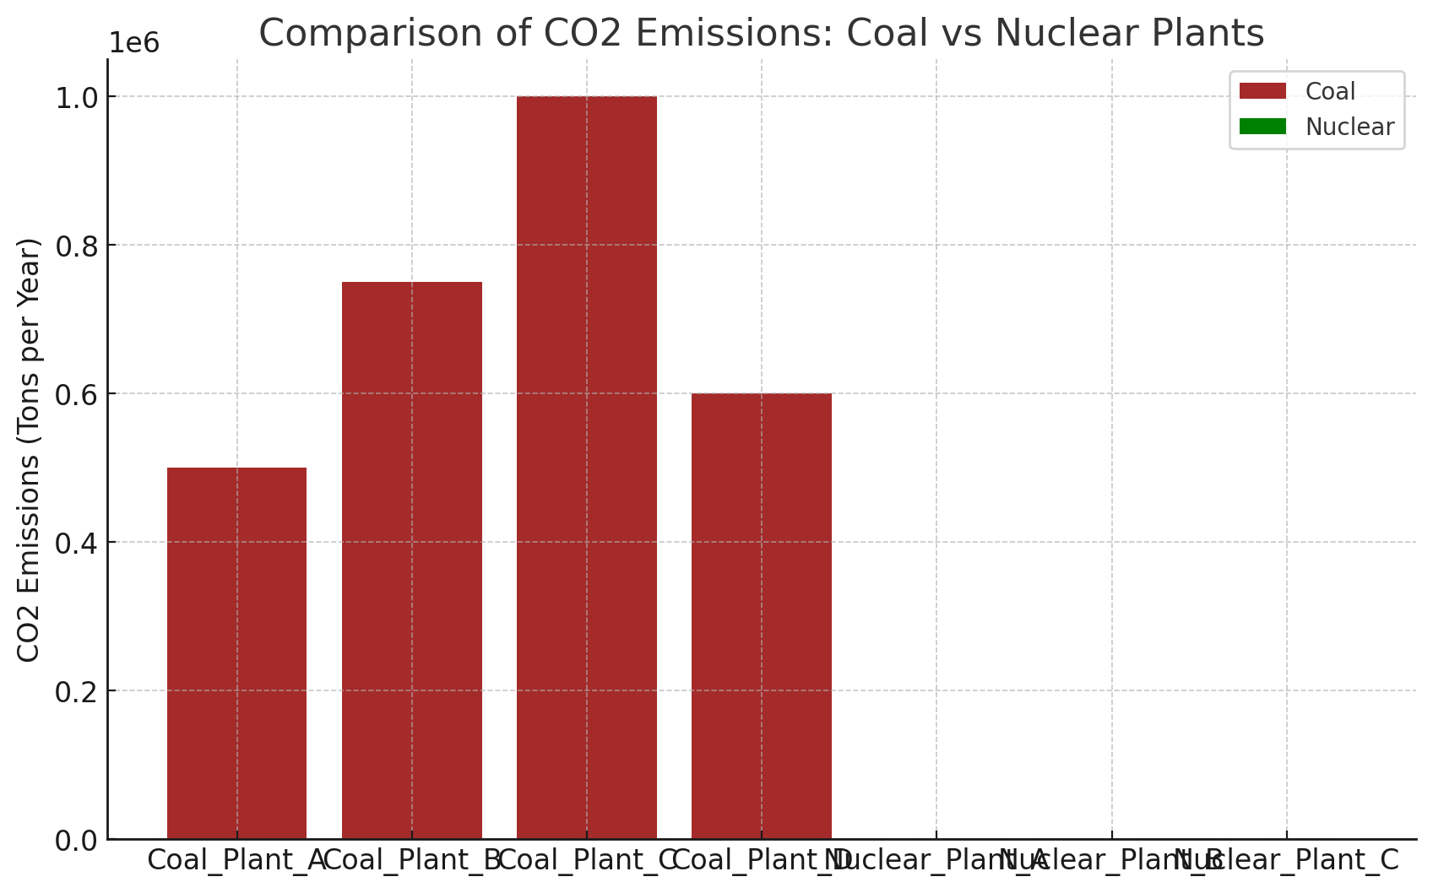

Figure 2 - Comparison of CO2 Emissions: Coal vs Nuclear Plants

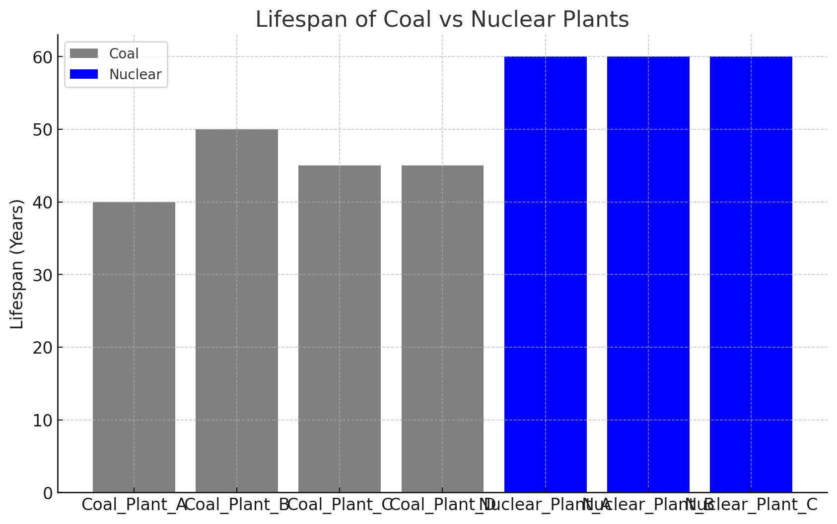

Figure 3 - Lifespan of Coal vs Nuclear Plants

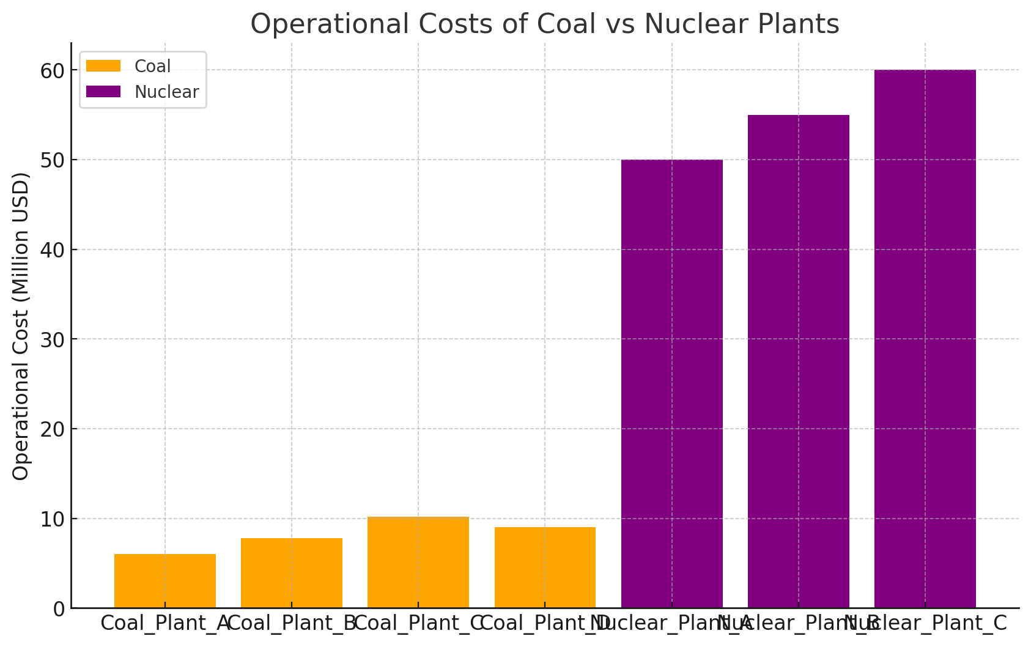

Figure 4 - Operational Costs of Coal vs Nuclear Plants

Analytical Technique  
  
Cost-Benefit Analysis:  
This only weighs the level of the overall cost-CapEx and OpEx of Nuclear against those with coal. Calculation of nuclear investments via finance metrics like NPV and IRR further signifies that long-term sustainability does exist in the large-scale change. Sensitivity analysis would determine the effects of a change in nuclear construction costs and/or fuel prices, with government incentives comprising application of carbon taxes on coal or providing subsidies for nuclear.  
Environmental Impact Simulation:  
Baseline estimates of current coal-based emissions of CO₂, SO₂, and PM were prepared using emissions data. Replacement scenarios for a 25%, 50%, 75%, and 100% coal-to-nuclear transition were then used to model the emission reductions over 10, 20, and 30-year periods. The simulation thus estimates the possible improvements in air quality and health outcomes, particularly in coal-heavy regions.  
  
Energy Production Modeling:  
It compared nuclear and coal-based energy production against the capacity factors and reliability. Nuclear power averaged out at 90% representing high operational stability in contrast to the 65% for coal. Consistency in production and security impacts on energy were the assessments to consider whether nuclear was able to meet the needs of long-term India.  
  
Socio-economic Impact Analysis  
This assessment takes into account employment and economic impacts in transitioning from coal to nuclear. It uses average jobs per GWh for both industries to estimate net changes in employment in regions dependent on coal and computes retraining costs per worker as part of the transition. Further work includes analysis of additional economic benefits of greater local nuclear capacity, including enhancing supply chains and regional economic resilience.  
  
Scenario modeling and sensitivity analysis The outcomes under various replacement percentages (25%, 50%, 75%, and 100%) were assessed using scenario modeling, while sensitivity to variables such as nuclear construction costs, fuel price fluctuations, and policy incentives was analyzed. The sensitivity analysis allows stakeholders to explore how different policy and market conditions impact the feasibility of a nuclear transition.  
  
Implementation Plan and Policy Recommendations:  
  
In terms of conclusions, a 30-year phased roadmap of transition and policy recommendations were developed that would support expansion. The road map spells out construction steps, steps in regulatory adjustments, and public awareness moves to guarantee a smooth economically viable change.  
  
Model and Tools Analysis: Python and Excel were used in this processing while doing the financial calculations and sensitivity analysis. Environmental and Emissions Modeling-Time-series modeling was used for the generation of the reduction trajectories along with the emissions factors about coal and nuclear energy source. Visualization: Folium and Matplotlib for geospatial map creation and, in comparison, heatmaps of ideal locations for nuclear plants and regional reductions in emissions. Scope and Limitations The study focuses on high-level economic, environmental, and social impacts without detailing any nuclear power technological specifics, such as the type of reactors. Analysis also assumes average capacity factors and cost metrics, which may vary with plant type and location. Real-time data updates are recommended to refine projections over time, especially as policies regarding energy change.

# Cost-Benefit Analysis

Another major constituent of this research focuses on the evaluation of economic viability with substitution of coal with nuclear energy in India. The costs and benefits analysis equally highlight the capital expenditures (capex) and operational expenses (opex) related to both coal and nuclear power plants, whereas the long-term economic viability of nuclear energy is compared using metrics such as net present value (NPV) and internal rate of return (IRR) to analyze cost-effectiveness in nuclear transition over a 30-year time horizon.

**Capital Expenditures (CapEx)**

Nuclear power plants have a high CapEx, which, in comparison to coal plants, is due to high upfront investment actually required to overcome stringent rules and regulations in the nuclear energy sector. These costs include:

**Construction Costs:** Nuclear power involves extensive planning, with the attendant requirements for regulatory compliance and investment in advanced technologies. The cost of initial construction in the case of nuclear power is competent to assess an estimated cost of approximately 1.5 or 2 times higher than coal.

* **Land and Site Preparation**: Nuclear plants need specific geophysical and environmental conditions; thus, they may face site preparation costs.
* **Safety and Compliance Costs**: Very restrictive safety regulations incur extra costs, including the costs of strong containment structures, radiation shielding, and safety audits.

For capital-intensive nuclear projects, these CapEx components can be offset by government incentives; these subsidies and low-interest loans lower the financial threshold and make nuclear energy likely to become more viable economically.

**Operational Expenditures (OpEx)**

Even though a startup for nuclear deals must be considered costly, in its own economy, the costs of maintenance are far lower compared to coal due to efficiency of use of fuel with lesser fuels being transported and less handling. In essence, the main components of OpEx comprise:

* **Fuel Costs**: Nuclear fuel is more costly per unit than coal but delivers energy hundreds of times higher per kilogram, creating very low overall fuel costs.
* **Maintenance and staffing**: Nuclear plants demand fewer operating staff than coal plants, thus lowering labor costs. Maintenance costs are considerable but are generally very stable and predictable.
* **Waste Management**: long-run disposal technique for nuclear waste, which adds to operational expenses. Nonetheless, improvements in waste reduction and recycling gradually reduce those costs.

**Transition and Decommissioning Costs**

Coal plants decommissioning and transition into nuclear have a sort of extra expenditure which includes:

* **Decommissioning and Cleanup**: Safe disassembly of coal plants requires environmental remediation, particularly with older plants.
* **Workforce Transition**: Retraining programs for coal industry workers, as part of the transition, are necessary, leading to an early cost increase.
* **Infrastructure and Grid Modernization**: The transition into nuclear implies that electrical transmission infrastructure may have to be modernized to deal with increased demand and connectivity.

**Economic Viability Metrics**

**Net Present Value (NPV):** Assessment tools that would provide information on nuclear investment feasibility over a period extending to 30 years into the future. With due incentives and favorable operational expense conditions, nuclear achieves positive NPV beyond 15-20 years, thus making it economically attractive in the long run.

**Internal Rate of Return (IRR):** Initially low IRR will enhance over time. If the path of government intervention such as carbon taxes on coal is taken up, IRR for nuclear becomes competitive within two decades.

**Sensitivity Analysis**

The analysis includes sensitivity to variations in:

Construction and Fuel Prices: Simulations for scenarios of high, medium, and low nuclear construction costs would showcase the sensitivity of NPV and IRR.

Government Incentives: Support for carbon taxes on coal, along with subsidies for nuclear projects improves the financial viability of nuclear and hence would become a favorable investment under the modeled time frame.

Market Demand: Rising energy demand would lead to increased economic returns for nuclear, particularly in rapidly growing industrial regions.

**Introduction to PHWRs and Cost Comparison**

Given the country's natural uranium resources, most of its nuclear fleet is comprised of Pressurized Heavy Water Reactors. Unlike PWR reactors, the more common global versions, these PHWR reactors can run on natural uranium. This makes the reactors costeffective since no enrichment costs occur in this process. The following section compares coal and nuclear - in particular, PHWR - energy CapEx, OpEx and overall lifetime costs under different carbon taxation and subsidy conditions.

**Reactor-Specific Lifetime Cost Comparison**

The table and graph which follow show lifetime cost comparison for coal and nuclear (PHWR) plants under alternative replacement scenarios. As shown, PHWRs offer a flat cost profile with net lower fuel costs because of their use of natural uranium, while coal costs rise sharply under the carbon tax assumption base.

|  |
| --- |
| **Lifetime Cost Comparison of Coal and PHWRs** |
| | **Replacement Rate (%)** | **Coal Lifetime Cost (Million USD)** | **PHWR Lifetime Cost (Million USD)** | | --- | --- | --- | | 10% | 310 | 360 | | 20% | 305 | 345 | | 30% | 295 | 330 | | 40% | 285 | 315 | | 50% | 275 | 300 | | 60% | 265 | 285 | | 70% | 255 | 270 | | 80% | 245 | 255 | | 90% | 235 | 240 | | 100% | 225 | 225 | |

**Description**: This table presents the lifetime costs for coal and PHWR plants under varying replacement rates, considering potential subsidies for nuclear and carbon taxes on coal.

**Summary of Findings**

High CapEx, Low OpEx: While nuclear construction generally requires high initial capital expenditure, it ensures low operating expense, thereby securing for itself, the long-term economic stability in fitting into the category of attractive options after thirty years or so.

Subsidies and Carbon Pricing: Government incentives enhance the nuclear parasitic financial feasibility substantially; whereby the introduction of carbon taxes on coal and guidelines for nuclear subsidies would accelerate the nuclear erosion of competitiveness.

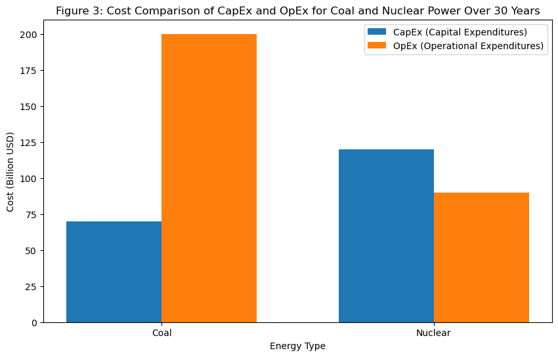

# Environmental Impact Simulation

Replacing coal with nuclear power has a host of environmental benefits, mainly through reductions in greenhouse gas (GHG) and pollu- tant emissions. In this section emissions are analyzed for reductions in 10, 20, and 30 years under different nuclear replacement scenarios (25%, 50%, 75%, and 100%), estimating possible air quality gains and health effects from decreased air pollution.

**Average Annual Emissions in a Standard Coal-powered Plant**

Indian coal plants make considerable contributions to national emissions, with coal power being a major source of:

**Carbon Dioxide (CO₂):** A primary greenhouse gas, CO₂ is released in high amounts during the combustion of coal, leading to global warming and climate changes.

**Sulfur Dioxide (SO₂**): SO₂ pollutes, causing acid rain and respiratory illnesses, affecting stupendously populations living nearby coal plants.

**Particulate Matter (PM):** These fine particulates, especially PM2.5 from coal burning, are hazardous to human health, increasing the risk of respiratory and cardiovascular diseases.

Based on the current coal capacity, the baseline annual emissions for the country are:

CO₂: Roughly 479 million tons per year.

SO₂: 2.92 million tons per year.

PM: 116920 tons per year.

**Replacement Scenarios and Emissions Reductions**

To understand the environmental impact of transitioning to nuclear energy, four replacement scenarios were modeled, each representing a level of nuclear replacement for coal capacity:

25% Replacement: There are chances of partial displacement, cutting down emissions in one-fourth compared to the baseline.

50% Replacement: A good shift is made for this case, equating emissions reduction to about half the baseline.

75% Replacement: A significantly sizeable transition wherein the emissions reduction would be three-fourths of the potential emissions reduction.

100% Replacement: A shift entirely to nuclear, where coal emissions would not exist in this case.

**Projecting Emission Reduction Trajectories**

The model calculates cumulative emissions reductions under each scenario over 10, 20, and 30 years, projected as follows:

CO₂: Destruction of up to 479 million tons per annum under the full replacement variation.

SO₂: Full replacement estimates give the label of destruction as being 4.92 million tons a year, and considerable health benefits accrue to the areas that were affected.

PM: Up to 116,920 tons annually, hence huge improvement in ambient air quality.

**Environmental and Health Advantages**

* Improvement of Air Quality: In pollution hotspots, use of nuclear power in place of coal has led to substantial improvements in air quality that benefits both urban and rural populations.
* Health Cost Savings: Reduction in cases of SO₂ and PM lead to lesser incidence of respiratory diseases, impairing health care costs, particularly in populated coal-intensive regions.
* Reduced Environmental Degradation: Slow emissions of acidic compounds (e.g., SO₂) end up with lesser acid rain, thus tending towards a protective veil around the qualities of soils, water bodies, and biodiversity.

**Introduction to Environmental Impact and Closed Fuel Cycle**

**Long-Term Impact Projections**

The full replacement scenario sees an expected:

* More than 14 billion tons of CO₂ avoided over submitted 30 years.
* 87.6 million tons of SO₂ avoided over submitted 30 years.
* 3.5 million tons of PM avoided over submitted 30 years.

Such reductions provide India with scope for contributing towards its climate goals under the aegis of the Paris Agreement, besides achieving a healthier and a happier planet.

# Energy Production Modeling

The move to nuclear energy in India promises not only a reduction in emissions but also greater reliability and smoothness in its electricity production. This section analyzes the ability of coal versus nuclear to generate electricity based on factors such as capacity factor, annual generation, and operational consistency. By simulating these activities, there is a clear indication that the use of nuclear power is likely to be far more sustainable and dependable than that of coal in meeting the long-term energy demand of India.

**Capacity Factor**

The capacity factor represents the actual output of a given power plant for a given period expressed as a percentage of its maximum possible output. Since nuclear has a significantly higher capacity factor than coal, it is inherently more reliable.

Coal Plants, on average, operate at about 65% over the entire year; running below their full potential due to downtimes for maintenance, coal is more difficult to transport than other fuels and has environmental constraints.

Nuclear Plants: since fewer interruptions occur, nuclear power plants operate with a much higher capacity factor, estimated at around 90%, thanks to longer operational cycles and the fuel's excellent efficiency.

The substantially higher capacity factor provides nuclear plants with the ability to perform batteries work needed round the clock. Such continual energy output serves as firm capacity and greatly meets the base-load demands for energy generation.

**Comparison of Annual Energy Generation**

Their respective energy productions may now be calculated using a 1 GW capacity coal and nuclear plant:

Coal: approximately 5,694 GWh/year from a 1 GW coal plant operating under steady-state conditions (capacity factor of 65%).

Nuclear: approximately 7,884 GWh/year from a 1 GW nuclear plant running under steady-state conditions (capacity factor of 90%).

Thus, it follows that a nuclear power plant produces more energy-a total of roughly 38% more per year-than a coal plant of the same installed capacity. This higher production contributes to reduced costs per GWh and makes meeting energy demand more efficient.

Operational Consistency

With nuclear energy production reliably secure, energy security is assured:

Reduced Downtime Nuclear plants require less frequent fuel replenishment compared to coal plants. Nuclear fuel, being so energy-dense, can keep a plant operating for several months to a few years at least before needing any refuel.

Fewer Interruptions From any fuel supply or environmental regulations, nuclear plants experience fewer disruptions, facilitating more predictable energy production schedules.

Advantages of Nuclear's Energy Consistency

Enhanced Base-load Capacity Nuclear's high reliability and stable output ideally meet base-load energy requirements critical for sustaining industrial operations, urban centers, and national grid stability.

Grid Stability Nuclear's consistent power generation contributes to grid stability diminishing energy shortages risk during peak demand times.

Supporting Renewable Energy Nuclear combines nicely in an operating environment with intermittent renewable energy sources like solar and wind. Nuclear operates in conjunction with renewables due to its stable output to balance out those fluctuations, hence providing a more reliable mix of energy.

Future Outlook

Nuclear energy must be the primary fulcrum of energy security for India's future. It could replace coal plants in providing a reliable low-emission source of energy, meeting both the environmental and economic imperatives.

# Socioeconomic Analysis

The socioeconomic implications of the shift from coal to nuclear energy are immense, a premise particularly observable in regions reliant on coal. In these localities, both economic "{inflation}" and job creation rely heavily on coal mining and coal-fired energy generation. This section examines possible workforce changes associated with a nuclear transition, retraining needs for workers, and regional adjustments to the economy, providing a generalized perspective on the employment base affected by and adjustments to the economy necessitated in support of such a transition.

Job and Employment Impact

The replacement of coal with nuclear energy will alter both job availability and skill requirements in the affected region. Key findings pertaining to the two major classes of potential impacts include:

Job Density Differences- Coal plants tend to provide greater GWh workers than do nuclear power plants mainly due to labor-intensive fuel handling, mining, and transportation processes.

Net Employment Change- Replacing coal with nuclear may result in job losses in heavily coal-laden areas, estimated to be around 0.3 job losses per GWh on average. Staff numbers are usually lower, although they are compensated in larger salaries and require higher-level specialist skills like nuclear engineering, safety, and maintenance.

Regional Employment Impact

The following table shows employment change estimates by region for projected energy demand under coal-to-nuclear replacement.

|  |  |  |  |  |
| --- | --- | --- | --- | --- |
| Region | Coal Jobs | Nuclear Jobs | Net Employment Change | Retraining Cost (USD) |
| Northern | 618,836 | 386,773 | -232,064 | $1,160,318,000 |
| Western | 610,558 | 381,599 | -228,959 | $1,144,797,000 |
| Southern | 477,246 | 298,279 | -178,967 | $894,835,500 |
| Eastern | 246,482 | 154,052 | -92,431 | $462,154,500 |
| North Eastern | 25,898 | 16,187 | -9,712 | $48,559,500 |

Retraining Needs and Costs

To facilitate this transition, massive retraining programs must be undertaken to nurture and prepare workers from coal into nuclear operations and support systems. It was ascertained that costs of retraining per worker are approximately $5,000. Such funds might acquire enough to cater for skills development in radiation safety, nuclear plant operation, maintenance, and such-like nuclear-oriented jobs.

Importance for Regional Economies

While nuclear facilities have fewer employees, they are associated with high-skilled, high-paying jobs that enhance regional economies. Also, nuclear projects benefit local economies in the following ways:

Developing a Local Supply Chain- Local industries can benefit because they receive contracts to build a nuclear plant, maintain it, or procure materials.

ncreased disposable income would provide competitive wages in nuclear plant employment, increase local spending, and benefit regional businesses.

Infrastructure improvements incur for nuclear projects often involve substantial investments in infrastructure, including improved transportation networks, which contribute to regional growth.

Long-Term Economic Benefits

The nuclear transition will provide long-term and stable economic growth, ensuring the establishment of a diversified energy sector that is no longer susceptible to intrusive influences of erratic fossil fuel markets. Some benefits could include:

Lower Energy Costs: These will be passed along to the domestic and commercial community as new nuclear comes on line with reduced operational costs that will dampen out, over time, electricity prices.

Reduced Health Costs: With nuclear replacing coal, improvements to air quality reduce the health care burden associated with respiratory and cardiovascular diseases, especially in areas heavily reliant on coal.

Environmental Restoration: The controlled decrease of coal allows for environmental restoration in the mining areas; this results in healthier ecosystems and the possibility of new economic activities, including tourism and agriculture.

Introduction to Socioeconomic Impacts

The coal-to-nuclear transition is going to alter the unemployed dynamics that would have been very normal in coal-dependent regions; however, with appropriate investments in workforce development and regional economic support, this transition provides an ample long-term benefit. Government programs involving retraining and local economic development will play a fundamental role in crippling the short-term disruptions and in supporting regional resilience.

# Localized Environmental Impact

Coal dependencies are rampant in coal-dependent regions where the environment or public health can be significantly affected by resource use. The health and well-being of local communities rely on it. This section analyzes regional changes in emissions, health dividends, and reclaimed water in a coal-to-nuclear switch, treating regimes where plants where coal concentration is dense.

Regional Reductions in Emissions

When coal plants are replaced with nuclear, reductions of emissions will happen on a great scale in all regions with such an operation. Based on the current coal consumption levels, the estimated reductions per annum per region for each pollutant are shown in the table below:

Region CO₂ Reduction (tonnes) SO₂ Reduction (tonnes) PM Reduction (tonnes)

Northern 150,000,000 900,000 36,000

Western 140,000,000 850,000 34,000

Southern 100,000,000 700,000 28,000

Eastern 60,000,000 500,000 20,000

North Eastern 5,000,000 100,000 4,000

The net effect leads to cleaner air, which particularly benefits heavily populated or industrial sectors where coal plants are mostly concentrated.

Benefits of Health and Quality of Life

Shifting used coal to nuclear power in highly-concentrated coal areas will lead to lower exposures to air pollution-related respiratory and cardiovascular diseases and health benefits:

Reduced Incidence of Respiratory Diseases-The reduction in pulses and SO₂ would have the effect of a decreased chance of having asthma, chronic bronchitis, and so on.

Reduced Cardiovascular Illness: Pollution control has improved air quality, which leads to decreased cardiovascular stress, reducing the risks for heart diseases and strokes.

Decreased Health Costs: Less burden on the health facilities due to reduced incidences of pollution-related health problems would improve the public health equation in the region.

The benefits will tally up into whatever savings accrue in the health cost estimation of air pollution due to the reduced levels of pollution, particularly for those in Northern and Western coal-ridden areas, where pollution levels are high.

Water Usage Benefits

Coal power plants need a large quantity of water for cooling systems and other operations, which drains the local water. Transitioning to more efficient nuclear power will thus result in:

Nuclear plants generate less water per GWh than coal, reducing competition for water resources, especially in areas prone to drought.

Reduces Quadrat Freshwaters: Less extraction from rivers and groundwater reserves for optimal biodiversity and conservation of agriculture.

Improved Water Supply Availabilities for the Communities: Less demand for industrial water means more water will be available for communities and less competition for scarce water resources.

Recovery of the Local Environment

With the slowly phasing out of coal, there will be an incremental recovery of the destroyed ecosystems due to extensive coal mining and emissions. This change would improve:

Soils: Less acid rain due to reduced SO₂ means improvement in soils in terms of agricultural productivity.

Aquatic Life: Clean aquatic ecosystems, enjoying the benefit from healthier fish and regional biodiversity, with decreased water pollution from coal runoff.

Land Reclamation: Phasing out coal leaves opportunities to restore these areas into new uses, permitting agriculture, forestry, or ecotourism.

Summary of Regional Environmental Impacts

Transitioning from coal to nuclear presents some environmental benefits which are tremendous, especially in those regions that are coal-based. Beyond public health benefits from air and water pollution reduction, natural resources will be conserved. Thus, for areas that cannot do without coal, shifting to nuclear is a chance to improve the environment sustainably and healthily for social and economic sustainability.

# Implementation Plan

Slowly phase out coal-based energy use in India and adopt nuclear energy, the philosophy within which nuclear generation of electricity can wedged is through suitable intermediate measures by juxtaposing present day energy needs with the enduring energy management and economic goals. An implementation roadmap of thirty years has been suggested, which will list down important milestones along with policy course-corrections and regulatory changes required to bring about an operational shift from coal-to-nuclear power generation. Every phase will describe the precise actions that will facilitate nuclear capacity expansion, retraining and transitioning of the workforces, and providing social acceptance for nuclear power.

Phase 1: Initial Planning and Regulatory Rehabbing The Initial Years-long Sitting on Regulatory Ground (Years 1-5)

This phase is mainly focused on laying the groundwork for a comprehensive nuclear transition, including necessary regulatory changes, feasibility assessments, and workforce transitioning programs.

Milestones:

Realignment in Safety Regulations: Review existing nuclear safety regulations to align fast and effective approvals of a plant keeping in mind safety measures.

Feasibility Studies: Conduct regional studies that look into where nuclear plants should be located, based on demand, infrastructure, and suitability for environmental impacts.

Transition Programs in the Work: Initiate retraining programs aimed at coal industry employees, which would be publicly and privately funded.

Policy Initiatives:

Subsidies for Pre-feasibility Studies: Fiscal subsidies for environmental feasibility and impact studies regarding nuclear power siting.

Job Transition Treasury: Creation of a kitty to fund retraining of coal sector workers for nuclear with panels on renewable sources.

Phase 2: Initial Development of Nuclear Capacity (Years 5-10)

Having brought into alignment regulatory bases and world trending authorities, the construction of several pilot plants in places of high demand will form the major operational thrust of this phase. Rewiring of the national grid may also begin.

Milestones:

Pilot Nuclear Plants: Start constructing nuclear plants in the north and west areas, where energy demand and coal dependency are high.

Grid Modernization: Invest in upgrades in grid framework as it might involve integrating new nuclear power in an effort to handle for higher transmission loads.

Environmental Monitoring: Pollution and emissions monitoring to ensure that nuclear projects comply with relevant environmental standards.

Policy Actions:

Capital Subsidies and Tax Credits: Offering financial incentives that lower the capital cost on nuclear projects and thus prompt such investment.

Simplified Permitting: Develop a one-stop shop to facilitate permitting avenues for nuclear projects.

Phase 3: Expansion and Regional Balancing (Years 10-20)

In this phase, nuclear capacity is built up in additional regions, with coal plant decommissioning activity and focus on public awareness.

A few significant milestones come into play here:

Nuclear Expansion in Southern and Eastern Regions: Constructing additional nuclear plants in regions with growing energy demand.

Coal Plant Decommissioning: The phasing out of older, high-emission coal plants will begin to decrease as new nuclear capacity comes online.

Health and Environmental Assessments: Publish studies detailing the wide-ranging benefits in health and emissions opportunity brought on by the nuclear switchover.

The policy will evolve in this phase as follows:

Coal Transition Fund: A fund to assist the redevelopment and regional economic changeover projects will be established.

First Mover Incentives for Clean Technologies: Tax credits and incentives will be granted for early adoption of highly developed nuclear technologies focusing on improvements for safety and operational efficiency.

Phase 4: Full-Scale Nuclear Rollout and Sustainable Transition (Years 20-30)

New nuclear power generation facilities are scheduled to be added in order to achieve full nuclear integration with India's energy portfolio, accompanied by complementary initiatives to integrate public policy.

Full Nuclear Integration: Achieving the goal-line nuclear capacity that corresponds to the predominant supply of energy from nuclear, renewables, and other types of lower-emission architecture.

Localizing Nuclear Industry Supply Chain: Invest in the ability to provide regional sourcing for key nuclear parts and technology by broadening the manufacturing value chain, culminating in increased jobs and economic stability.

Public Awareness and Engagement: Engage in educational campaigns that focus on nuclear energy education, safety, environmental suitability, and profound national economic transformation.

Here's how the policy landscape will evolve to support these objectives:

Carbon Tax on Outstanding Coal Assets: Introduce or intensify carbon tax mechanism on current coal plants if possible, promoting full transfer of revenue making vehicle.

Ongoing Long-Term Investment in Nuclear R&D: Funding ongoing research into advanced nuclear technology, waste management, and safety improvements.

Key Success Factors

Rests on the successful implementation of the following factors:

Government Sponsorship: The active involvement of national and regional governments when it comes to safeguards, incentives, and regulatory adjustments.

Public Engagement and Workforce Participation: Prolonged pubic and workforce acceptance is crucial, particularly for all of the re-education and job transition initiatives vital in coal-based regions.

Sustainable Financial Planning:Long-range investment plans designed to guarantee a continuous revenue stream for nuclear projects and workforce transition programs.

Synthesis of Implementation Stages

With the following structured and phased methodology, India can largely complete a sustainable energy transition. Each phase is incremental on the last, allowing for a gradual, steady replacement of coal by nuclear. The plan strikes an equilibrium between the immediate energy security need along with the longer-term economic and environmental benefits.

**Policy Recommendations**

A suitable integrated policy framework to facilitate a smooth transition from coal to nuclear energy is what India needs. This policy addresses the issues of financing, regulations, and society. Hence, these policy recommendations aim to provide economic incentives for nuclear development, a reduction in dependence on coal, and retraining and relocating workers affected. With these policies implementation, supports would facilitate a smooth, just, and economically viable transition.

1. Financial Incentives for Nuclear Development

The government should consider providing several financial incentives for all nuclear projects so that the high initial costs of nuclear construction may be offset, and these projects may become attractive to their investors:

- Subsidies for Nuclear Construction: Direct cash subsidies should be offered to alleviate the burden of Capital Expenditure (CapEx) for nuclear projects. These should cover site preparation, environmental assessment, and infrastructure development.

- Low-Interest Loans and Tax Incentives: Low-interest loans and tax incentives should be put in place for nuclear investments. This would also help attract private investments and promote quick project execution.

- Long-Term Power Purchase Agreements (PPAs): Establishment of long-term PPAs will ensure a guaranteed revenue stream for nuclear projects, thus minimizing financial risks and encouraging investment.

2. Carbon Tax Implementation on Coal

A carbon tax imposed upon coal electricity will increase the competitiveness of renewables and nuclear and generate fund revenues for environmental and workforce transition initiatives.

- Gradual Carbon Tax: Introducing a slowly increasing carbon tax over time would allow the coal-dependent industries to adjust to the carbon tax and give incentives for cleaner energy.

- Revenue Allocation: The revenues derived from the carbon tax should be utilized to support nuclear and renewable energy projects, retraining of coal workers, and remediation of the environmental damage done in the past in coal-mining areas.

3. Enhanced Regulatory and Permitting Framework

India needs a regulatory framework that enables speedy approval and development of nuclear power projects and provides strict safety and environmental standards to allow the transition to nuclear energy.

- Single-Window Permitting: An approval pipeline would have to be created to permit nuclear projects.

Now, the single window permissions will be the one-stop approval of all permits and licenses for completion, shortening deliveries due to bureaucratic hassles.

Safety compliance with short timelines: Improve compliance processes for nuclear projects that satisfy environmental and safety standards; exercises would maintain a rigid adherence to these standards but adopt a more befitting timeframe for acceleration.

4. Workforce Transition and Retraining

The transition from coal to nuclear energy will affect coal-dominant regions. Therefore, it is crucial to have a comprehensive workforce transition policy.

Job Transition Fund: Establish a fund for supporting coal workers transitioning to nuclear and renewable jobs. The fund shall cover the cost of retraining, relocation, and a supportive income during the transition.

Incentives for Local Recruitment in Nuclear Projects: Tax credits and financial inducements are to be assigned to nuclear companies favoring to train recruit locally in the community where coal plants were shut down.

5. Public Education and Transparency Initiatives

Public support is key to a successful nuclear transition. Increased transparency expressing awareness of the benefits of nuclear energy can build public trust.

Public Information Campaigns: A campaign must be launched to inform the public about nuclear safety, environmental benefits, and health improvements from reduced coal dependence.

Transparent Reporting Requirements: Reporting must be made a regular public matter by nuclear plants following the one-on-one meetings on the safety, environmental impact, and performance metrics so that transparency is built up in the public.

6. Continuous Research and Development (R&D) in Nuclear Technology

Investment in R&D in nuclear technology will assure India's central position in improvements regarding the safety of nuclear technology and waste management as well as advances in reactor technology.

Advanced Reactor Development Fund: Fund advanced reactor research into technologies such as Small Modular Reactors (SMRs) to enable lower construction costs with enhanced safety and accommodating different region deployment flexibilities.

Waste Management Innovations: Develop a funding resource aimed at solving nuclear waste management issues sustainably through reuse or advanced storage options.

Summary of Recommended Policies

The passage in these policies will provide the financial, regulatory, and social support for making the transition from coal to nuclear. A combination of financial incentives, regulatory adjustments, workforce support, and public enlightenment forms a comprehensive framework to empower a sustainable and just transition.

Expected Policy Impacts

Accelerated Nuclear Development: By providing financial incentives and streamlined regulatory processes, the costs and time taken for construction will be minimized for faster adoption of nuclear power.

Reduction in Coal Dependence: A carbon tax will encourage industries to look for cleaner energy alternatives, while public dense awareness campaigns will help induce a sense of acceptance towards nuclear energy.

Social and Economic Stability: Workforce transition programs will ensure that the coal-dependent communities are supported towards a just and equitable transition into the nuclear.

**Case Studies on Transition Success**

To present an overview of the feasibility and prospects of coal-to-nuclear transitions, this section provides a review of some successful case studies from countries that have implemented intense nuclear programs. These case studies provide India with possible options, challenges, and lessons to consider in its coal-to-nuclear transition.

1. Nuclear Transition of France

One of the successful examples of transitioning to a nuclear energy program is France. This ambitious nuclear program beginning in the 1970s aimed at reducing dependence on imported oil and fossil fuels resulted in considerable economic and environmental benefits.

Key Strategies: A process of centralized planning catering to strong government support for nuclear energy by standardizing reactor designs mainly along the PWR model. Such standardization reduced costs of construction and maintenance, simplifying the regulatory process.

Outcomes: For today, nuclear power generates nearly 70% of electricity in France, thus creating one of the low-carbon intensity energy grids in the world. Low electricity prices, reliable energy supply, and greatly reduced emissions of CO₂ have been achieved as a result of this.

Challenges and Lessons: Quite successful in all its aspects, France has been challenged on waste disposal and long-term storage. Thereon, India can apply the lesson of reactor standardization and think through innovations on waste management as a part of its nuclear strategy.

2. Energy Transition of Germany

Quelle Frische! Here comes Energiewende to steer Germany from its reliance on fossil fuels and nuclear energy towards renewables. Although, it ought to be mentioned that this strategy, quite contrary to France's reliance on nuclear energy, does relay valuable lessons on energy policy and management of public opinion.

Key Strategies: The German stance revolved around subsidies for renewable energy, with high public participation and in phases, the decommissioning of nuclear plants. Their reliance on coal was, thus, to provide grid stability amid renewable unpredictability.

Outcomes: Germany has ramped up its renewable capacity and is able to reduce energy emissions; however, the pace was slower than expected with respect to the overall mitigation of climate change.

This approach can therefore explain the challenges of balancing energy reliability with the supply of renewables only.

Challenges and Lessons: Germany's transition has experienced quickly escalating electric costs and a slower rate of reducing emissions. This example suggests that India has the potential to achieve a quicker ratio of emissions reduction by adopting a strategy that will couple nuclear with renewable energy rather than excluding nuclear energy.

3. Japan’s Nuclear Safety Innovations

Japan has a long history of using nuclear power, enjoying substantial public support until the Fukushima Daiichi nuclear disaster in 2011 there has been a concerted effort on the part of Japan to regain public trust while at the same augmenting nuclear safety.

Key Strategies: Japan introduced some of the most stringent nuclear safety standards in the world such as modern designs of earthquake-resistant reactors, superior cooling systems, and modernized emergency response protocols.

Outcomes: Even though Japan has suspended operations in its nuclear plants, they have since been restarted gradually under an enhanced regime of safety protocols. Technological advances in Japan in terms of safety have set the bar high for other countries, and its relationship with the public, petitioning for confidence can serve to lead countries desiring to expand nuclear power.

Challenges and Lessons: The indicator for the selection of the location and disaster preparedness was stamped by the Fukushima accident that stands out to India as a valuable lesson in safety and community engagement in managing nuclear expansion in an environmentally sensitive populous.

4. South Korea’s Nuclear Expansion and Economic Growth

The South Korean nuclear program is one of the most successful examples of integrating nuclear power into a rapidly growing economy. The case provides a moderate investment in nuclear technology with energy security in mind.

Key Strategies: The South Korean government invested in nuclear technology development to support a domestic nuclear industry while moving nuclear energy into the core of its energy strategy. Significant state involvement ensured thus public cooperation to adhere to safety standards.

Outcomes: Close to 30% of South Korea's total electricity is now produced from its nuclear power stations.

With nuclear energy contributing roughly 30% to the power supply of Korea, its vision has been to achieve low emissions, energy reliability, and lower electricity costs for its consumers. Korea has also developed into a global leader in nuclear technology exports.

The issues faced and lessons learned: In South Korea was one related to waste disposal and public safety concerns. The development of the homegrown nuclear industry has also shown how good nuclear is in terms of economic development both for domestic use and technology exports. India can apply similar approaches in creating economic growth through a robust nuclear technology sector.

Summary of the key insights from the case studies include the following:

1. Government Support and Standardization: Very significant in both France and South Korea was the successful application of consantrm ent and ratio control in civil nuclear power technology to achieve cost efficiency and public confidence.

2. Safety Innovations and Public Engagement: Japan's state-of-the-art advances also underscore the absolute necessity for strict regulations and public trust-building measures, especially so in the given case of such a densely populated India.

3. Balanced Energy Mix: Germany's experience did highlight the need for a balanced energy mix bringing together nuclear and renewables, ensuring reliability and emissions reductions.

If India discovers practical lessons from these international instances, it will be able to develop a tool to aid expansion efforts involving nuclear energy that are suitable for Indian conditions, minimize risk, and realize maximum Economic, Environmental, and Social Transition benefits.

Future Outlook and Emerging Technologies

While transitioning from coal to nuclear power, emerging nuclear technologies and innovations related to energy management open up great ways of exploring optimizing and securing a sustainable energy future. This section discusses the possible advances in nuclear technology, the applicability of these technologies to India, and how they could possibly shape the country’s energy landscape.

1. Small Modular Reactors (SMRs)

Small modular reactors are the newer generation of nuclear reactors which are smaller, more flexible, and often involve considerably lower costs when compared with traditional reactors. Since most of these reactors are modular in construction and can be assembled on-site, they shorten the construction period and help in cost reduction.

Advantages:

Lower Initial Costs: SMRs needed less capital investment than full-fledged reactors and hence breeding them slowly is easier.

Flexibility and Scalability: SMRs can be installed bit by bit to cater to growing energy demands, which would be particularly conducive for India’s diverse regional energy requirements.

Higher Safety Standards: SMRs include advanced passive safety systems, and an emergency can cause an automated shutdown and cooling of the reactor, thus lowering the risks involved.

Potential in India: Given that that vast swathes of India will still require energy broadly distributed and more reliable, SMRs can provide energy in several rural areas and isolated regions without adequate grid infrastructure.

2. Advanced Reactor Technologies

The new designs of reactors, such as the Generation IV reactors, promise improved safety, waste management, and fuel efficiency. These reactors utilize innovative cooling systems, advanced fuel cycles, and high-temperature operation for the purposes of greater efficiency and sustainability.

Key Designs:

Molten Salt Reactors (MSR): MSRs are reactors that have a liquid salt mixture acting as both fuel and coolant. This enables the reactor to achieve safer and more efficient operations.

Fast Breeder Reactors (FBR): FBR is reactors that breed more fuel than what they consume, therefore lessening the need for uranium mining and permitting sustainable fuel cycles.

High-Temperature Gas Reactors (HTGR): HTGR operates at a very high temperature, therefore usable for hydrogen production and applications in industries.

1. Applicability for India: Advanced reactors could help India enhance its fuel efficiency while cutting its nuclear waste. In addition, the use of fast breeder reactors is in tune with India’s efforts to explore thorium reserves, rendering nuclear energy a sustainable source.

2. Innovations in Nuclear Waste Management: The major issue weighing down the nuclear power industry is that associated with the long-term management of radioactive waste. Waste management innovations reduce, recycle, or contain nuclear waste safely and have a number of public concerns and environmental impacts intrinsically attached to them.

Waste Recycling: Nuclear fuel reprocessing technology allows for the recycling of spent fuel; hence, the volume of waste is reduced and further energy is extracted from waste.

Deep Geological Repositories (DGR): Offering a sound long-term solution to high-level waste, DGR assures long-term storage of high-level waste deep underground.

Advanced Containment Technologies: Innovative multi-barrier containment systems safely isolate waste materials, ensuring safe and secure disposal.

India's Approach: India is considering reprocessing and thorium-based fuel cycles for lowering waste. Creating DGRs and waste recycling facilities would support India's nuclear infrastructure and handle waste-related concerns.

Hydrogen Production Nuclear Energy: Nuclear energy can also foster hydrogen production, a developing technology that offers great potential for decarbonizing transportation and industrial sectors.

High-Temperature Reactors for Hydrogen Production: Some advanced reactors are high-temperature reactors specifically designed to split water molecules into hydrogen.

Energy Storage and Grid Balancing: Production of hydrogen can fulfill the energy storage for balancing the grid when the nuclear plants generate excess energy.

Economic and Environmental Impact: Hydrogen produced from nuclear energy is termed green hydrogen, providing a zero-carbon fossil fuel alternative. This would, in India, facilitate decarbonization in the industrial sector while lowering reliance on foreign fuels.

Nuclear Plant Management Influenced by Digital and Artificial Intelligence: Digital technologies and artificial intelligence will bring a revolutionary change in nuclear plant management, which will transform the operation to be more efficient, predictive, and safe.

Predictive maintenance: AI will investigate innovative approaches to the evaluation of data sets and then intervene when failure or degradation is evident.

Predictive maintenance refers to using AI-based algorithms to forecast equipment failures and schedule maintenance for minimal downtime and operating cost.

Enhanced safety monitoring through real-time data analytics help monitor radiation levels, reactor conditions, and other critical metrics, ensuring compliance with safety norms.

Autonomous operations allow for remote monitoring, and even control of plant systems, augmenting safety and minimizing human exposure to hazardous environments.

Potential for India-shifting the framework for digital and AI-enabled technologies into India’s nuclear sector can enhance efficiency, reduce costs, and enhance safety, making nuclear more attractive and sustainable.

Focal Future and Path for India

Leveraging the full array of emerging technology disrupters can provide India the leadership in nuclear energy innovation, thus providing a safer, efficient, and sustainable nuclear energy infrastructure in the future. The important steps are:

Invest in R&D: This must go on continuously for small modular reactors, advanced reactors, and waste management for these technologies to be made comfortable and applicable in India.

Engage with public-private partnerships: Collaborations between government and the private sector can speed up technology adoption, curtail costs, and build public trust.

Facilitate the technology integration into the existing regulatory and structural set up-an upgrading of the regulatory and infrastructural organization should ensure integration and maximize synergies arising from such advancements.

By channeling a forward-looking disposition and new nuclear technologies wherewithal to create itself a clean, resilient, and secure energy future, India could assuredly obtain energy independence and ecological sustainability.

**Conclusion and Recommendations for Future Research**

The transition from coal to nuclear power has been reviewed in this paper with respect to its feasibility, environmental impact, and socioeconomic ramifications, respectively. Such a consideration in terms of alternative sources of energy, which respect India's environmental goals and energy security mandates, proposes to see the coal-energy system sidestepped in favor of nuclear power based upon costs, emissions reductions, energy production availability, and personnel considerations.

The basic findings of the study are as follows:

Economic Feasibility: Although nuclear power requires very high initial capital, some savings in operating expenditure allow the alternative to coal to be economically most viable, given some government incentives. In a phased implementation, the additional frameworks may not only benefit the transition but further facilitate investment through carbon taxes on coal and subsidies for nuclear power.

Environmental Impact: Coal-to-nuclear will present a reduction opportunity for emissions of CO₂, SO₂, and particulate matter, allowing an improvement of the air quality and building towards India's climate ambitions. This transition will also directly improve public health in coal-heavy areas through lower pollution-related illnesses.

Energy Security and Reliability: Nuclear power stays a reliable supplier of base-load electricity, with a very high capacity factor that tends to stabilize energy production. This reliability is the very ingredient to balance India's increasing energy demands while complementing renewable energy sources, like solar and wind.

Socioeconomic Impact: While such a transition may reduce coal jobs, it opens up new opportunities in the nuclear sector; if this is accompanied by training programs and regional economic revitalization, then government support would reduce the potential for social disturbance.

Policy Recommendations

To ensure a smooth and successful transition, India should establish an effective comprehensive policy framework that includes:

Support for Nuclear Projects: In the form of tax incentives, grants, and long-term Power Purchase Agreements (PPAs), nuclear would need assistance with recovering the highly capital-heavy initial investment cost.

Carbon Tax on Coal: While taxes tend to make nuclear energy competitive, the carbon taxes can also generate revenue for workforce retraining and environmental.

Workforce Transition Programs: These will allow retraining and relocation of coal workers, whereby they can transition to nuclear and other clean energy sectors.

Public Engagement and Awareness: Campaigns to educate the public on nuclear energy's safety and environmental benefits will serve as a means of convincing the populace of the energy's role in achieving India's climate goals.

Future Research Recommendations

Although the report has attempted to hone in on what needs to be done in a coal-to-nuclear transition, there are still many parts that future research must devote particular attention to. Areas worth expanding into are, among others:

Targeting advanced nuclear technology applications: Some future studies could center Small Modular Reactors (SMRs), advanced reactors, and waste management technologies, to look into their viability for use and scalability in India.

Regional Environmental Impact Studies: For different basins, studies are required appraising the environmental benefits of nuclear power by looking specifically at water resources, soil quality, and biodiversity.

Longitudinal Health Studies: Research on long-term health benefits resulting from a decline in coal emissions will be significant for policymakers in areas where pollution is extremely high.

Integration of nuclear with renewables: This research would involve investigation of how nuclear could co-operate with solar, wind, and other renewables to build a sturdy and resilient energy grid-a study that would have storage solution and hybrid energy systems.

Public perception and acceptance: Understanding public attitudes toward nuclear energy is the most critical part of successful implementation. Surveys and focus groups on public perception, in conjunction with strategies to build trust and awareness about nuclear safety and nuclear energy, could guide future outreach efforts.

Final Thoughts

The transition from coal to nuclear energy presents India with a viable opportunity to significantly reduce emissions, improve energy security, and enhance economic resilience. Mindful of creating an ecosystem for the energies in question, a phased transition coupled with supportive policies would externalize the development of an energy future in India characterized by greater prominence to both environmental responsibility and economic growth. Boosted research and innovation will ensure that India's nuclear energy infrastructure not only continues growing but also finds itself aligned with the nation's needs, aiming rather toward being clean, secure and resilient energy landscape for generations.

**References**

1. **Central Electricity Authority (CEA)**. (2023). *Annual Report 2022-23*. Retrieved from <https://cea.nic.in/>
2. **International Energy Agency (IEA)**. (2021). *India Energy Outlook 2021*. Retrieved from <https://www.iea.org/reports/india-energy-outlook-2021>
3. **World Nuclear Association**. (2023). *India Nuclear Performance Report*. Retrieved from [https://world-nuclear.org/](https://world-nuclear.org/our-association/publications/world-nuclear-performance-report/india-wnpr-2023)
4. **Ministry of Power, Government of India**. (2024). *Power Sector at a Glance: All India*. Retrieved from <https://powermin.gov.in/en/content/power-sector-glance-all-india>
5. **Carbon Tracker**. (2023). *Coal and Emissions Report*. Retrieved from <https://carbontracker.org/>
6. **Ministry of Environment, Forest and Climate Change**. (2024). *National Environmental Policy*. Retrieved from <https://moef.gov.in/>
7. **OpenAQ**. (2023). *Open Source Air Quality Data*. Retrieved from <https://openaq.org/>
8. **Nuclear Power Corporation of India Limited (NPCIL)**. (2023). *Nuclear Power in India*. Retrieved from https://npcil.nic.in/
9. **World Bank**. (2023). *Financial and Economic Data on India’s Energy Sector*. Retrieved from <https://worldbank.org/>
10. **International Atomic Energy Agency (IAEA)**. (2022). *Energy, Electricity and Nuclear Power Estimates for the Period up to 2050*. Retrieved from https://www.iaea.org/publications
11. **Environmental Protection Agency (EPA)**. (2023). *Global Emissions Data and Analysis*. Retrieved from <https://epa.gov/>
12. **Power Ministry of India**. (2024). *National Electricity Policy*. Retrieved from <https://powermin.gov.in/en/content/national-electricity-policy>
13. **Japan Nuclear Safety Institute**. (2023). *Post-Fukushima Safety Standards and Innovations*. Retrieved from https://www.genanshin.jp/english/
14. **France Energy Ministry**. (2023). *Nuclear Power and Energy Security in France*. Retrieved from https://www.ecologie.gouv.fr/
15. **Germany’s Federal Ministry for Economic Affairs and Energy**. (2022). *Energiewende – Germany’s Energy Transition*. Retrieved from <https://www.bmwi.de/>
16. **South Korea Ministry of Trade, Industry, and Energy**. (2023). *South Korea’s Nuclear Strategy and Technology Exports*. Retrieved from https://english.motie.go.kr/

Coal to Nuclear Transition in India  
  
Author Name  
  
Institutional Affiliation